**Source of the Failure**

A mobile phone manufacturer has two manufacturing sites. Each site has 2 sites which produce:

* Screens
* Cameras

Factory 1 produces 70% and Factory 2 produces 30% of the total phones. The data provided gives the success and failures of 1000 components of each type produced by the suppliers (denoted by 1 and 2 for Factory 1 and Factory 2 respectively). The two phone manufacturing sites do not source from the same supply sites. Use the data provided and a probability tree to determine the following:

* What is the probability that a phone produced at factory 1 has its screen fail?
* What is the probability that a phone produced at factory 2 has its camera fail
* If a phone screen fails, what is likelihood it was produced at Factory 1?
* If a phone camera fails, what is likelihood it was produced at Factory 2?

Step 1:

Open the data file Sources of Failure.xlsx and look at the data. There are 4 columns describing component failures for source companies (component manufacturers). A 1 in a column means the component passed inspection, a 0 means the component failed.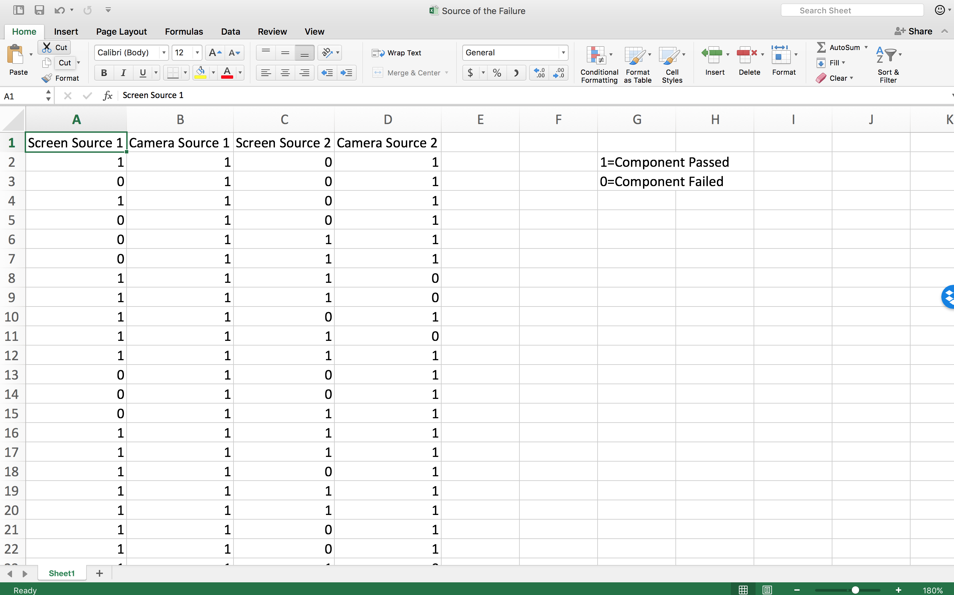

Step 2:

Build a table as shown to calculate the probability of failure for each component.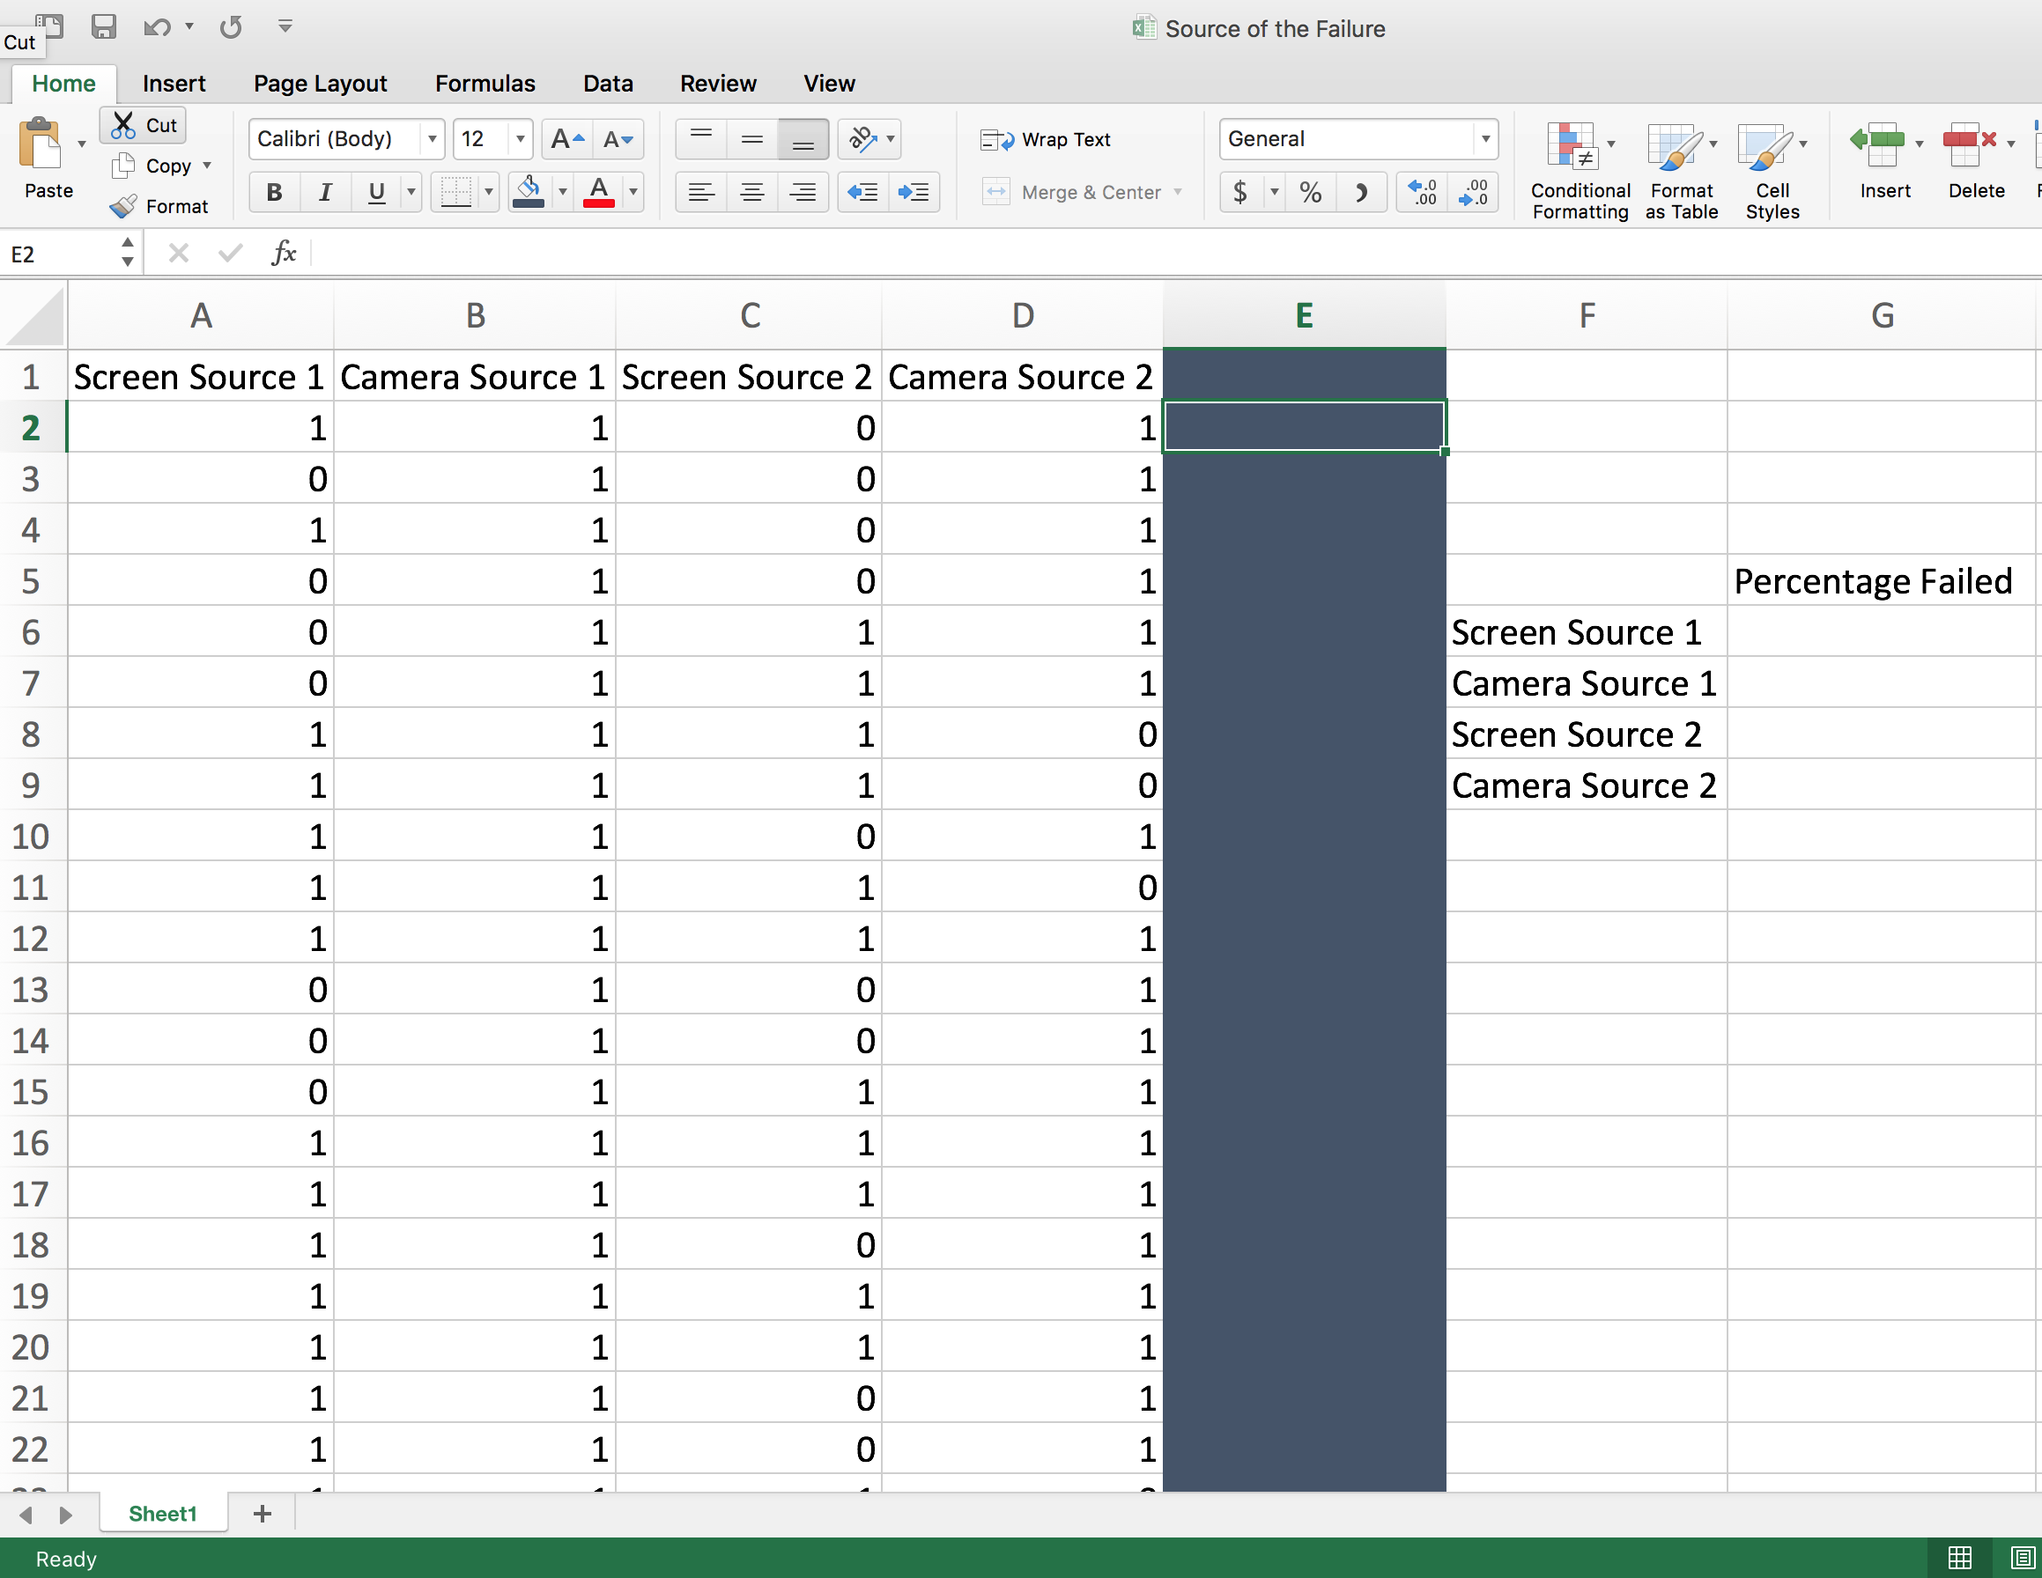

Step 3:

Using the COUNTIF() function, find and add all of the failures in each column.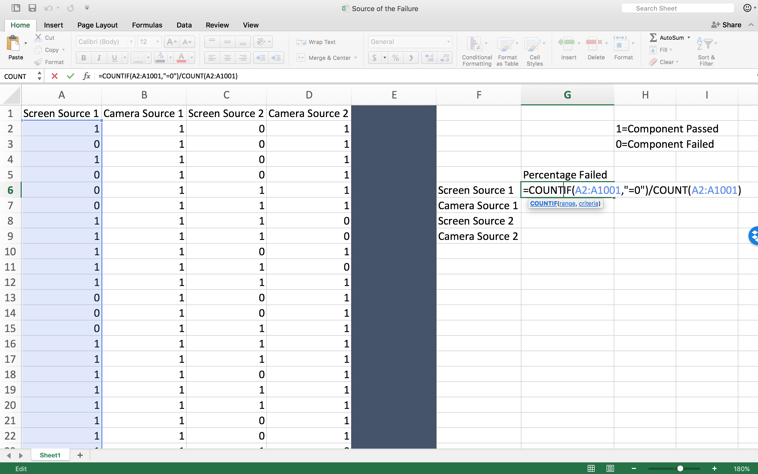

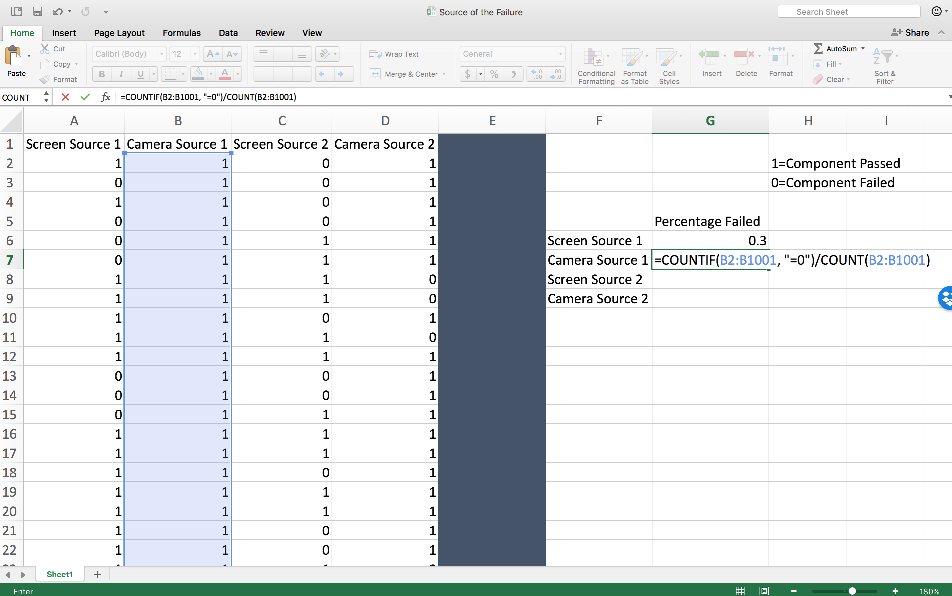

Step 4:

View the final results as decimals. These are the percentages of components that failed in testing.

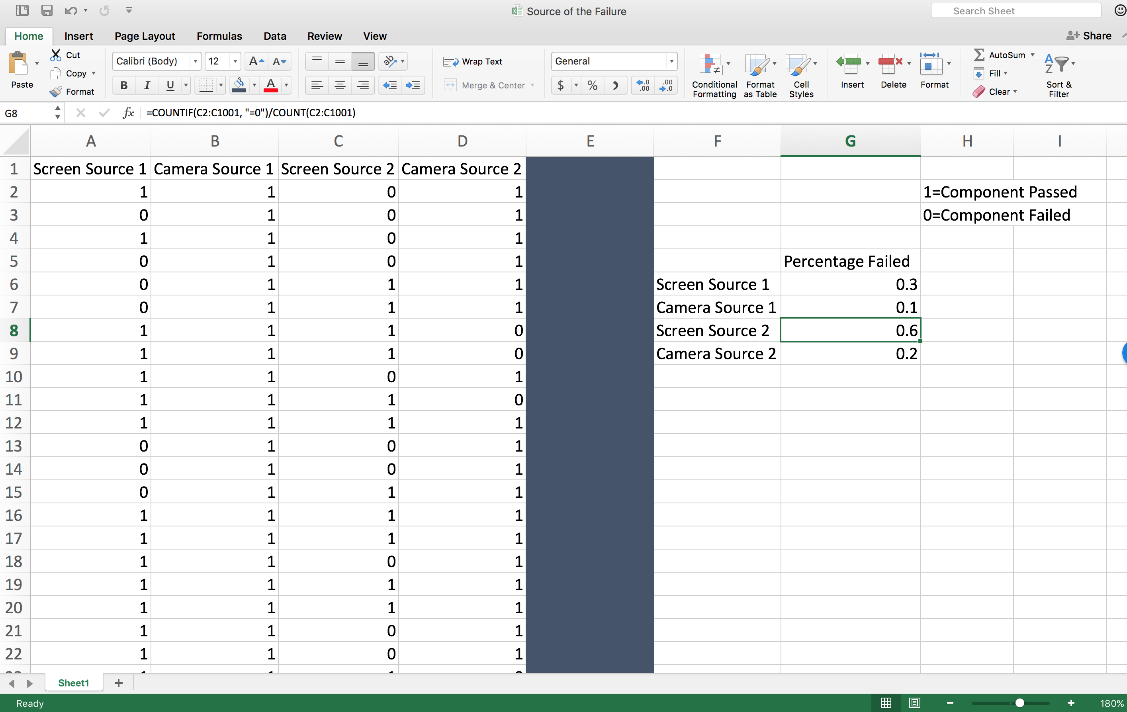

Step 5:

Build a probability tree reflecting the sourcing of the phone and its components.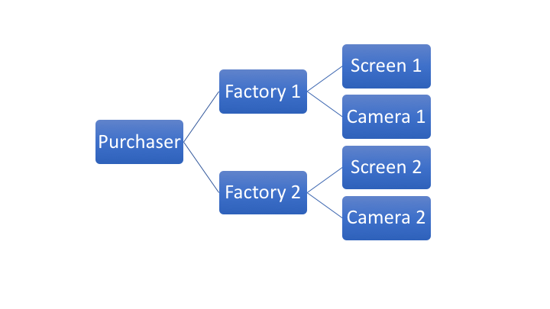

Step 6:

Fill in the probabilities that the phone was assembled at which factory in step 1 of the tree and the probabilities of failure in step 2 of the tree.

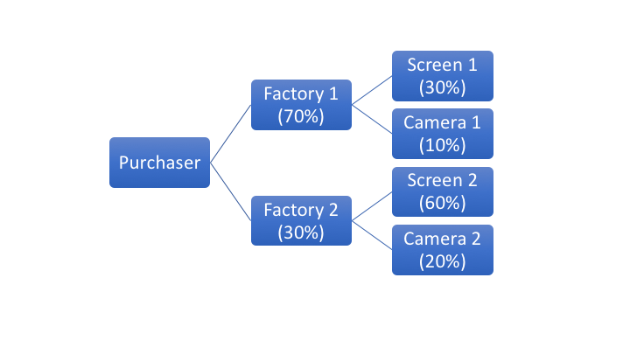

* What is the probability that a failed phone was produced at factory 1 and had a failed screen?  
  P(factory = 1, screen fails) = 0.70 * 0.30 = 0.21 or 21%
* What is the probability that a failed phone was produced at factory 2 and had a failed camera?  
  P(factory = 2, camera fails) = 0.30 * 0.20 = 0.06 or 6%
* If a phone screen fails, what is likelihood it was produced at Factory 1?  
  P(screen fails) = 0.7*0.3+0.3*0.6 = 0.39 (sum of probabilities along the tree for screen breaking)  
  P(screen fails | factory = 1) = (0.70*0.30) / 0.39 = 0.54 or 54%
* If a phone camera fails, what is likelihood it was produced at Factory 2?  
  P(camera fails) = 0.70*0.10 + 0.30*0.20 = 0.13  
  P(camera fails | factory = 2) = (0.30*0.20) / 0.13 = 0.46 or 46%